Crop Area Coverage Information System

http://aps.dac.gov.in OR http://aps.dac.gov.in/AreaCoverage

Introduction

CACIS is a web enabled information system which facilitates district wise and crop wise data entry and information retrieval of crop area sown on weekly basis. The system can be accessed from any and where any time over the Internet. The major features of the system are given below.

- Crop Area Coverage Information System is a web enabled work flow based system for state, district and crop directorate level officials which will be monitored at central level. Similarly state and directorate can also monitor the data submitted by district level officials.

- Effective progress monitoring by providing data reporting status and auto email or SMS alert to state/district/ directorate officials in case of delayed or non reporting of data to ensure timely submission of data.

- The system will provide online interface to enable crop area sown data flow from district, district to states, state to directorate and there-on to the DACFW after consolidation, validation/verification by states/districts/directorate.

- Data entry by district/states as per the prescribed format for selected crops and districts only.

- Facility to compare current data with past data.

- Provision for data status report and various summary reports as per requirement in various combinations of state, district, crop, year, season, week.

- Provision of weekly data entry interface for weekly area sown and quarterly data entry interface for quarterly area sown

Guidelines for Using Crop Area Coverage Information System

The user has to work with various modules of the system which are given below.

  - Login

  - Crop Selection
  - State Selection
  - District selection

  - Crop Area Sown

  - Normal Area

  - Target Area
  - Data Approval

  - Data Reporting Status

  - Reports

  - Logout

- Login

Browse the CACIS Portal as per link provided on first page in Internet Explorer or Google Chrome, a screen will appear as follows. Select your state/district/directorate from the dropdown list and enter the password provided by GOI. The temporary password is ac@2017 which may be used for the first time. Later on, password may be changed for security reason.

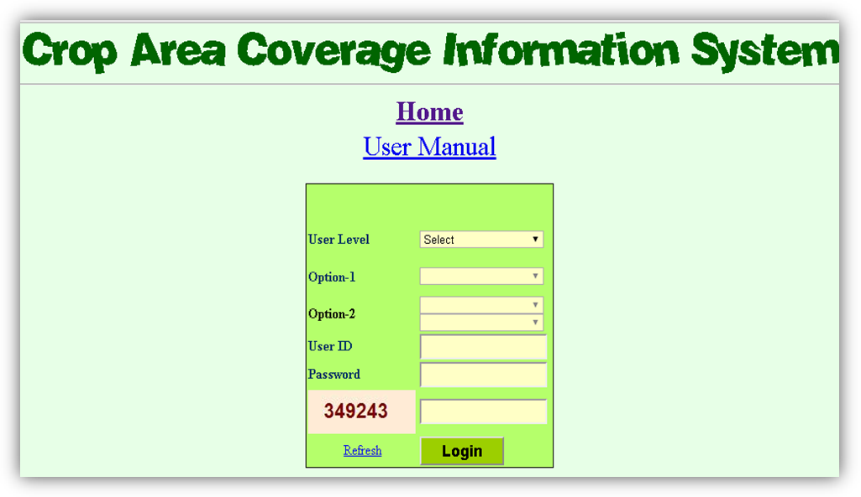

Select Central and enter the password, security code and Click on Login button. Following screen will appear after successful login.

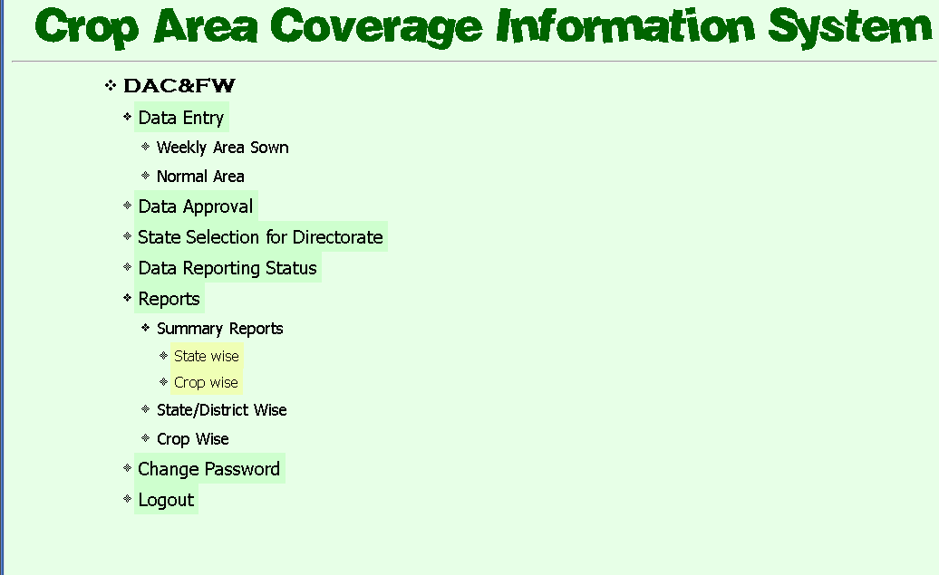

2. Crop Selection and Crop Order (State and District Level Officials Only)

First of all, state/district wise crops has to be selected which will help in data transmission of concerned crops instead of showing all the crops and performing data entry for relevant crops. This is one time job. Later on addition and deletion of crops may be carried out as per convenience.

Click Crop Selection and Crop Order option from Home page. A screen will appear as follows for State official.

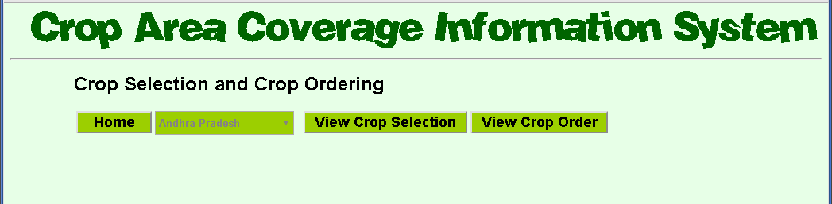

Click Crop Selection and Crop Order option from Home page. A screen will appear as follows for District official.

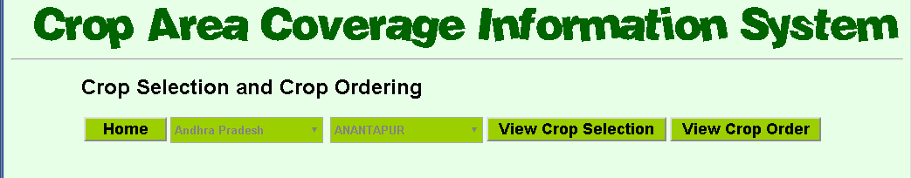

There are two button View Crop Selection and View Crop Order. Click on View Crop Selection and a screen will appear as follows for State level official. District level official will get a district name on this screen.

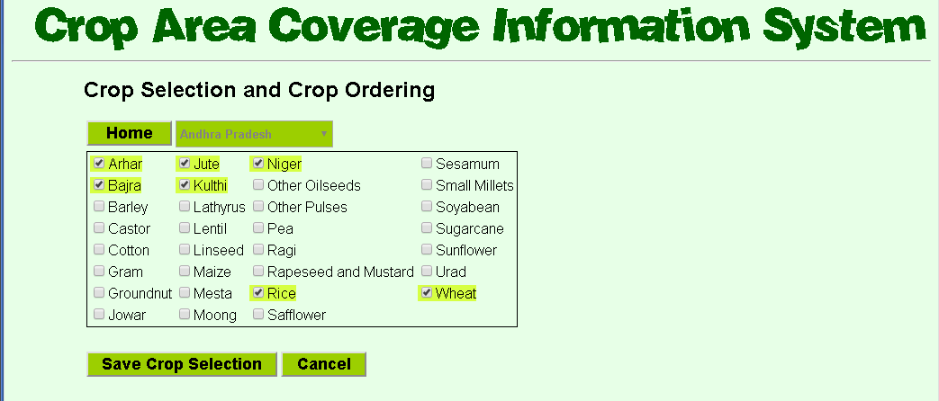

There are all crops listed. You are supposed to select crops grown in your state only. Click Save Crop Selection to save the selection. You will get a dialogue box to confirm the selection saved.

You can also set the crop order as per your requirement. By default crops are listed in alphabetical order. Click on View Crop Order button and a screen will appear as follows.

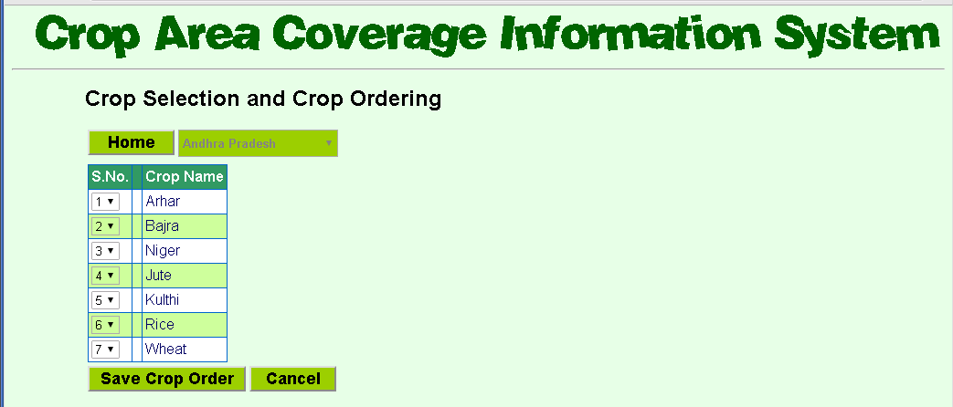

You can reorder the crops by selecting the S.No. from dropdown list in the first column. Click on Save Crop Order to save the reordering. A screen will appear to conform the saved crop order.

3. State Selection (DAC&FW Level Officials Only)
This option is used to set distribution of states among Crop Directorates. A screen will appear as follows after clicking this link.
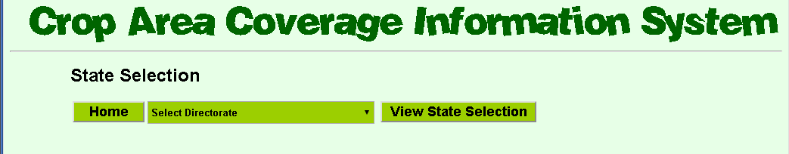
Select the Crop Directorate and click on View State Selection. A screen will appear as follows.
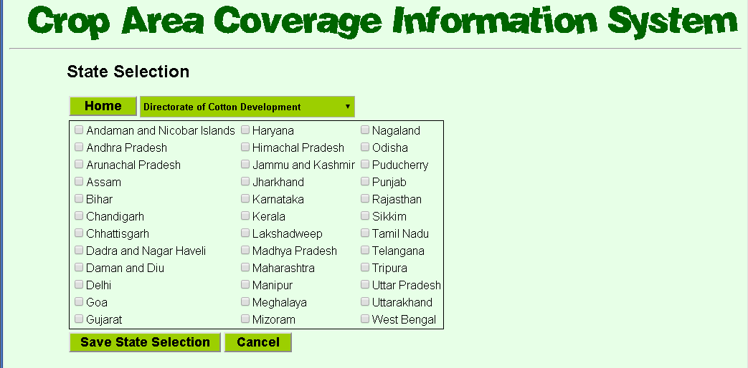

There are all state listed. You are supposed to select states allotted to the selected directorate. Click Save State Selection to save the selection. You will get a dialogue box to confirm the selection saved.
4. District Selection and District Order (State Level Officials Only)

State wise district has to be selected which will help in data transmission of concerned districts instead of showing all the districts and performing data entry for relevant districts. This is one time job. Later on addition and deletion of districts may be carried out as per convenience.

Click District Selection and District Order option from Home page. A screen will appear as follows for State official.

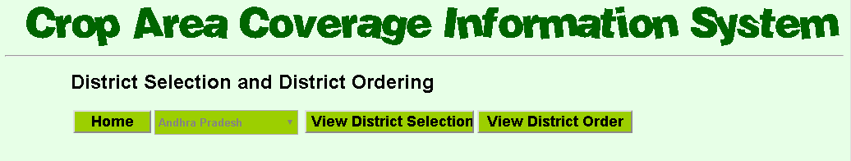

Click on View District Selection from the page to get the following screen.
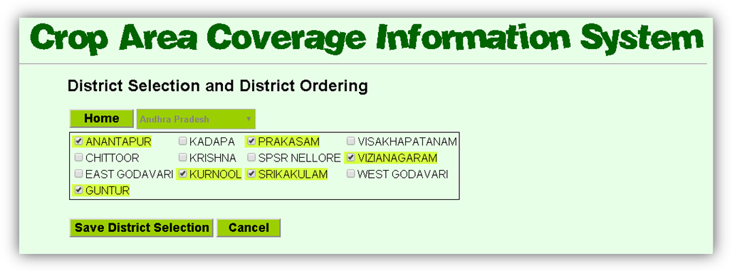
There are all District listed. You are supposed to select District allotted to the selected State. Click Save District Selection to save the selection. You will get a dialogue box to confirm the selection saved.

5. Crop Area Sown

This module is used to capture district wise, crop wise, season wise area sown on weekly basis. Click on Weekly Area Sown under Data Entry menu to display a screen as follows
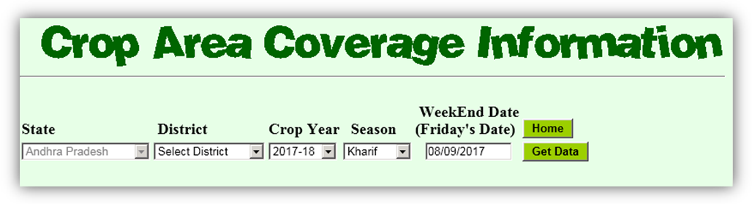

The state name will be auto selected if you are state level official. Kindly select state name in case of state is not selected. Select district from district dropdown. Crop Year and Season are auto selected based on last week’s week end date. Weekend Date is also auto populated as last Friday’s date. You may select other than last weekend date if required. Click on Weekend Date textbox to select a other date. A following screen will appear after you clicked Get Data button as follows.
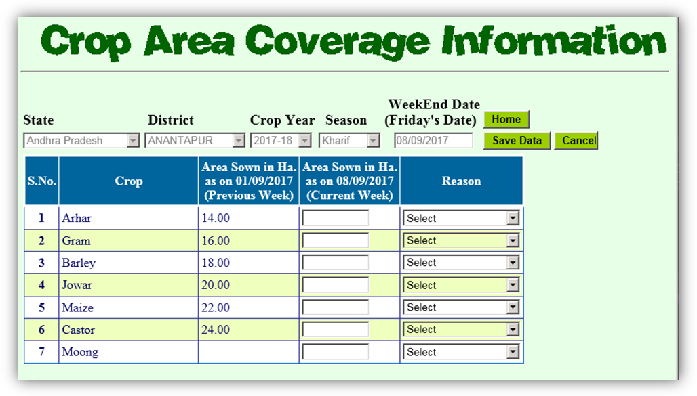

This screen will display the last week area sown and current week area sown data of selected week if already entered otherwise it will be a blank form. Enter the area sown against each crop in the respective textboxes. Changes to data can be done by changing the displayed data in the form. Click the Save Data button displayed at the top to save the data. A screen will appear to confirm you that data has been saved. If something goes wrong then an error page will be displayed.
Cancel button can be used to discard changes done in the data.

What is Week/Season/Crop Year?

A week has 7 days counted from Saturday to Friday. A week is represented by week end date in the database. Crop Year and season are calculated based on weekend date as follows.
Kharif Season – June to September
Rabi season -- October to January
Summer season – February to May
Crop Year – June to May

6. Normal Area (DAC & FW Official Only)

Click on Normal Area under Data Entry menu to display a screen as follows.
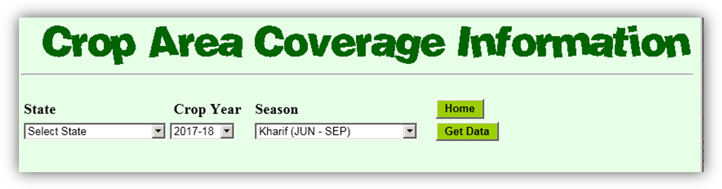
Select the state name, crop year, season and click on Get Data button to get a screen as follows.
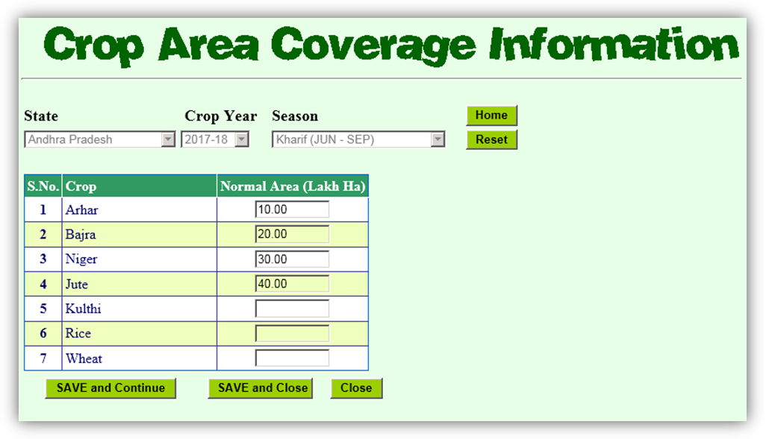
This screen will display the normal area sown data of selected parameters if already entered otherwise it will be a blank form. Enter the area sown against each crop in the respective textboxes. Changes to data can be done by changing the displayed data in the form. Click the respective Save Data button to save the data. A screen will appear to confirm you that data has been saved. If something goes wrong then an error page will be displayed. Close button can be used to discard changes done in the data.

7. State Target Area (State Level Official only)

Click on State Target Area under Data Entry menu to display a screen as follows.

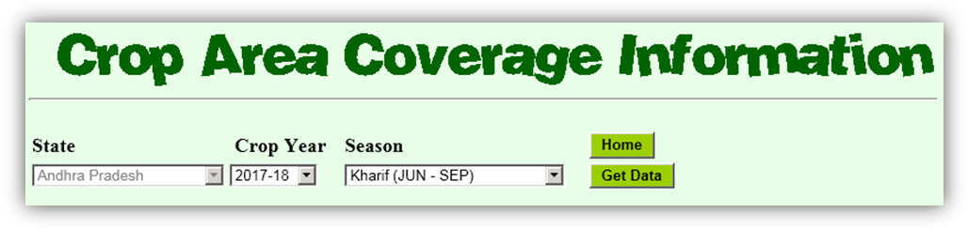
Select the state name, crop year, season and click on Get Data button to get a screen as follows.
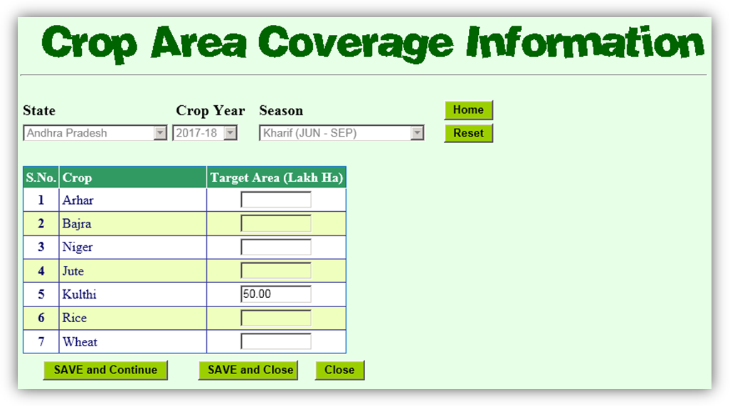

This screen will display the target area sown data of selected parameters if already entered otherwise it will be a blank form. Enter the target area against each crop in the respective textboxes. Changes to data can be done by changing the displayed data in the form. Click the respective Save Data button to save the data. A screen will appear to confirm you that data has been saved. If something goes wrong then an error page will be displayed. Close button can be used to discard changes done in the data.

8. District Target Area (State Level Official only)

Click on District Target Area under Data Entry menu to display a screen as follows.
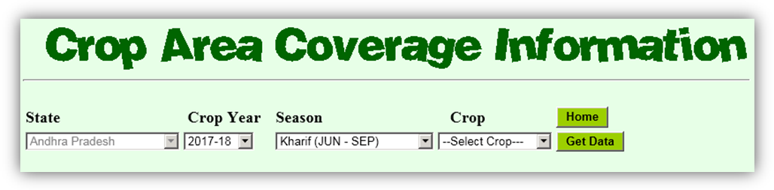

Select the state name, crop year, season, crop name and click on Get Data button to get a screen as follows.

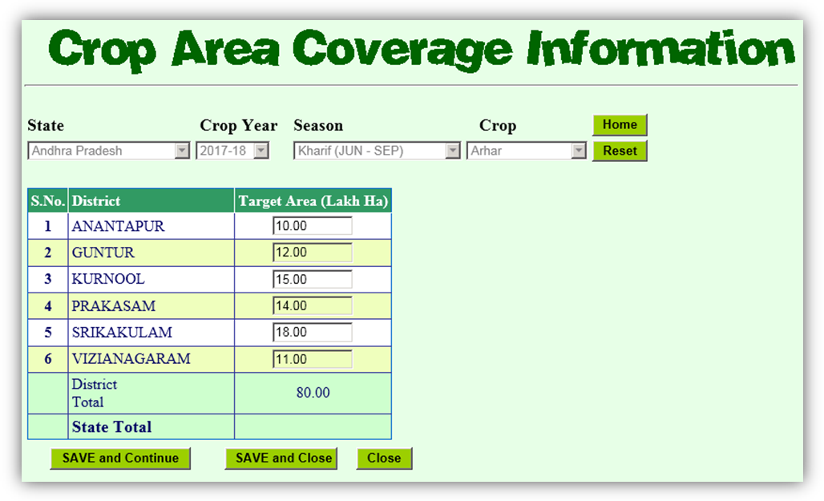

This screen will display the target area data of selected parameters if already entered otherwise it will be a blank form. Enter the target area against each district in the respective textboxes. Changes to data can be done by changing the displayed data in the form. Click the respective Save Data button to save the data. A screen will appear to confirm you that data has been saved. If something goes wrong then an error page will be displayed. Close button can be used to discard changes done in the data.

9. Data Approval

Click on Data Approval from home page to display a screen as follows

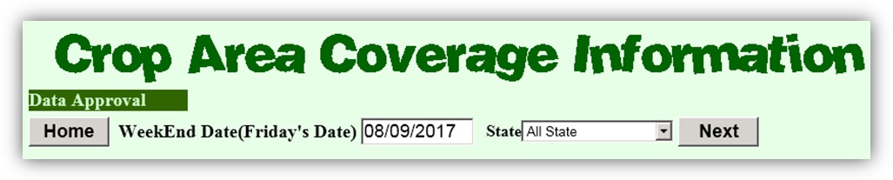

Select the week end date and click on Get Data button to get a screen as follows.

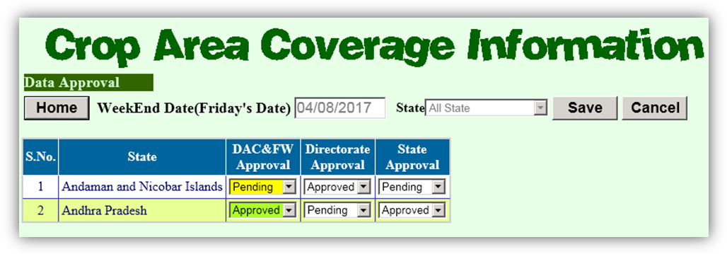

This screen will display the approval status at DAC&FW level, Directorate level and State level. Status is either pending or approved. The pending status indicates that data is entered partially or completely but not finalised by the concerned authority. It is the duty of concerned authority to update the status of data as soon as it is finalised otherwise this data will not be considered for report submission. Select the Approved option from respective dropdown to update the status and click Save button. A screen will appear to confirm you that data has been saved. If something goes wrong then an error page will be displayed. Cancel button can be used to discard changes done in the data.

Similarly data approval status may be updated district wise by selecting a state from the state dropdown.

10. Data Reporting Status

Click on Data Reporting Status from home page to display a screen as follows

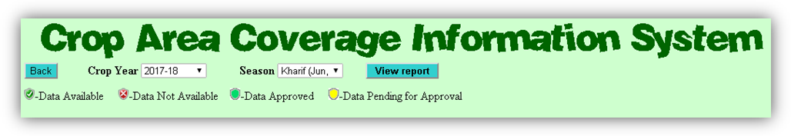

Select the Crop Year and Season from respective dropdown and click View Report a screen as follows will appear. If the user is state level than district wise status will be displayed.

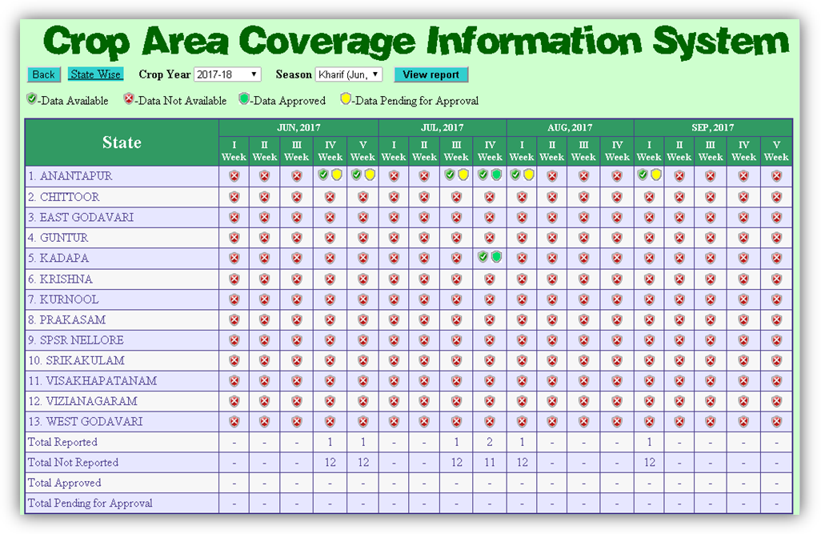
If the status is district wise, a hyper link will be displayed to view state wise report as follows.

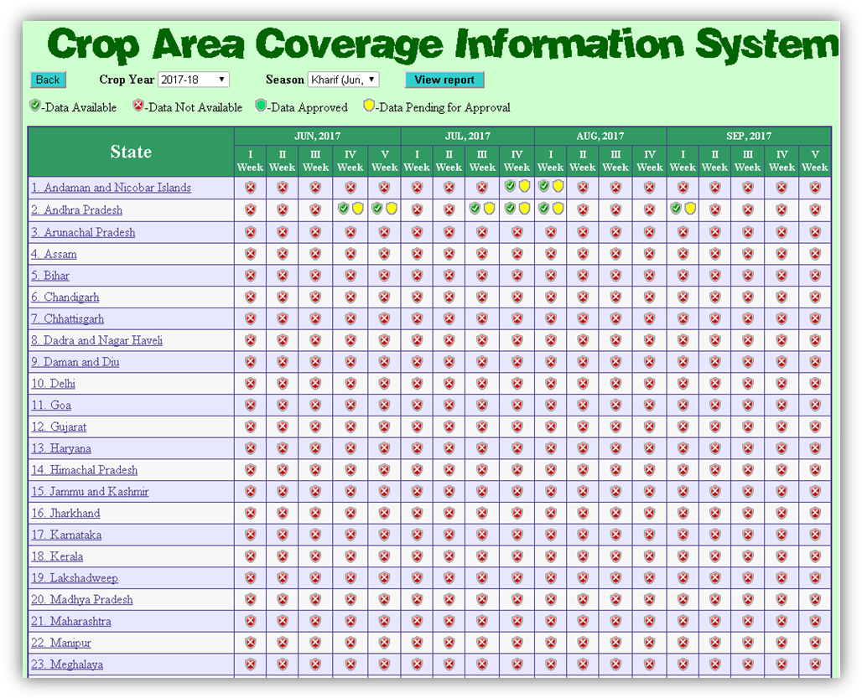

11. Reports (Standard Reports)

There are two types of reports, state wise/District wise and Crop wise, available under the Reports menu on Home page. Click state wise/District wise sub menu to generate a report. A screen as follows will appear.
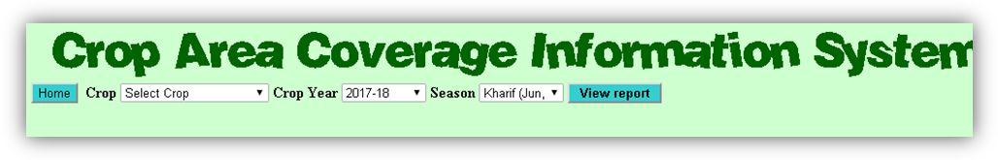
Select the Crop, Crop Year, Season and click on View Report a screen as follows will appear.
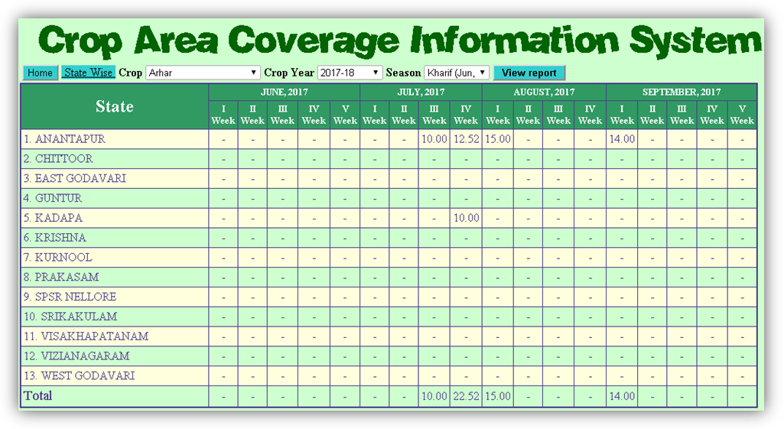
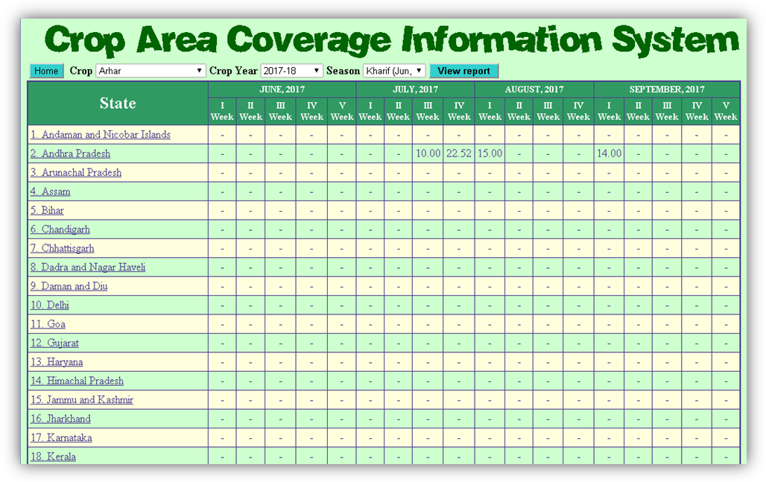

Click state Crop wise sub menu to generate a report. A screen as follows will appear.
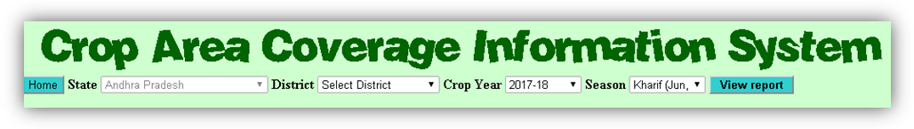

Select the State, Crop Year, Season and click on View Report a screen as follows will appear.
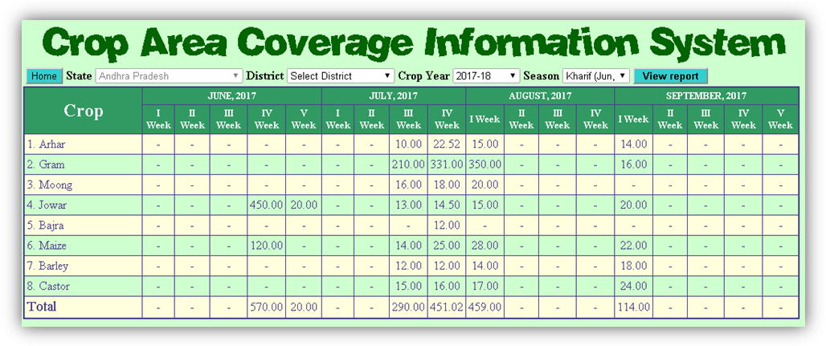
Select the State, District, Crop Year, Season and click on View Report a screen as follows will appear.
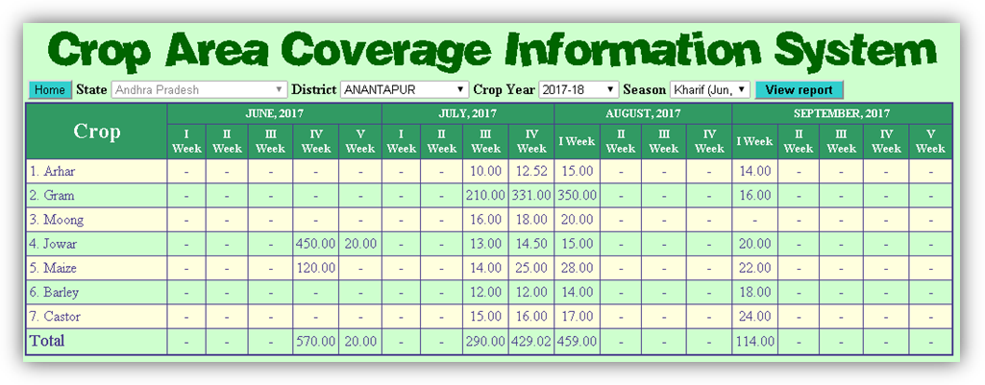

12. Reports (Summary Reports for DAC&FW)

There are two types of reports, state wise and Crop wise, available under the Reports menu and Summary Reports sub menu on Home page. Click state wise sub menu to generate a report. A screen as follows will appear.

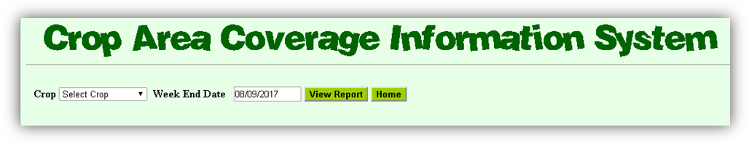

Select the Crop, Week End Date and click on View Report a screen as follows will appear.

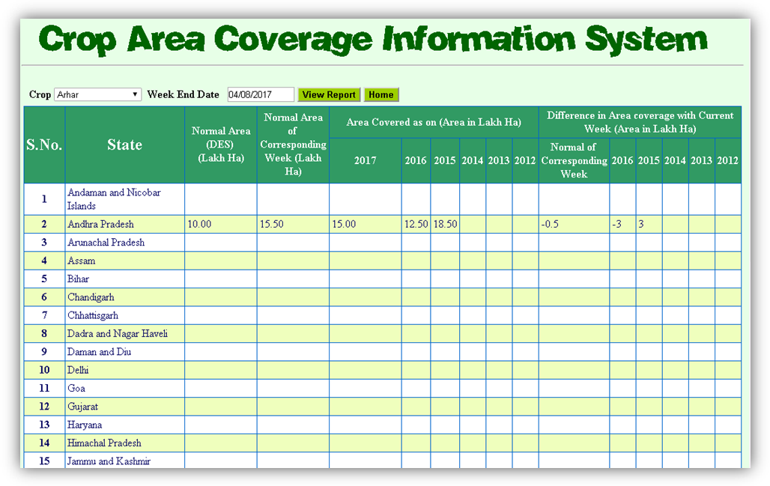

Click state wise sub menu to generate a report. A screen as follows will appear.

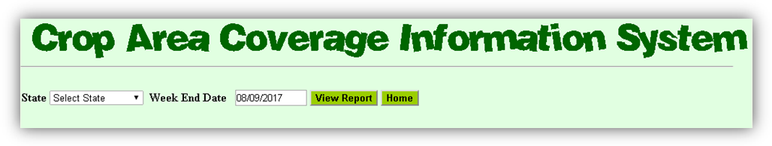

Select the Andhra Pradesh State, Week End Date and click on View Report a screen as follows will appear.

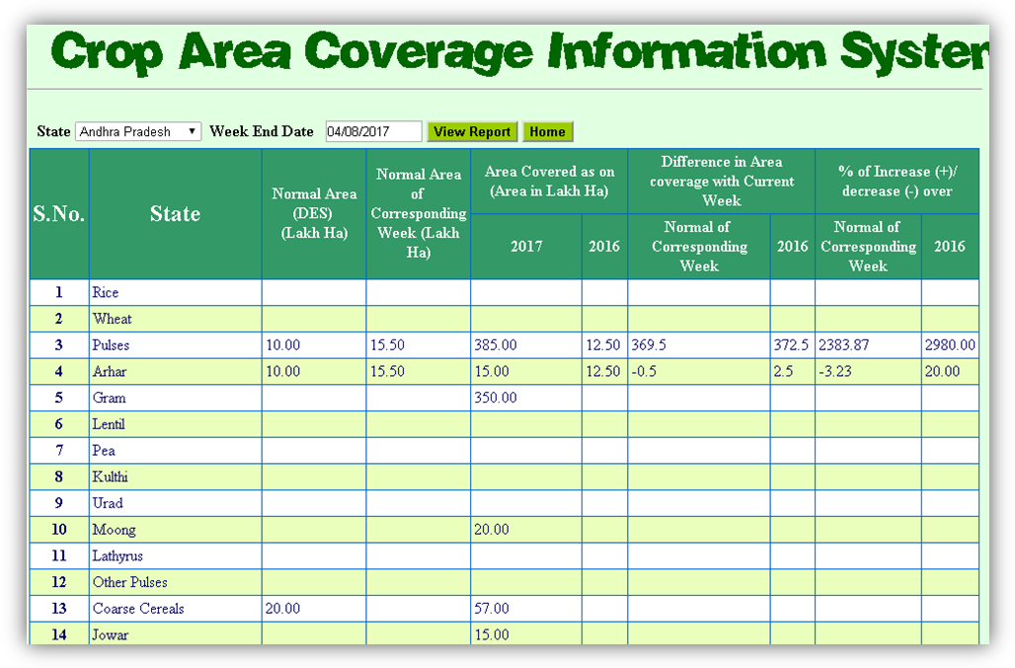

Select the All India, Week End Date and click on View Report a screen as follows will appear
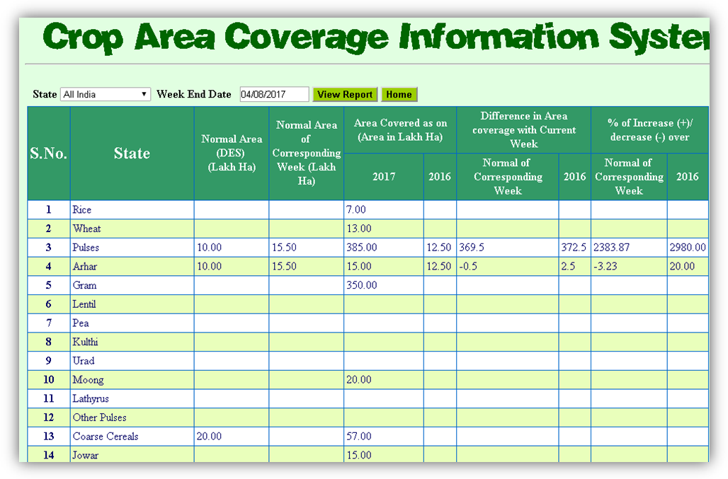

13. Change Password

Click Change Password menu from Home page to change your login password. A screen as follows will appear as follows.
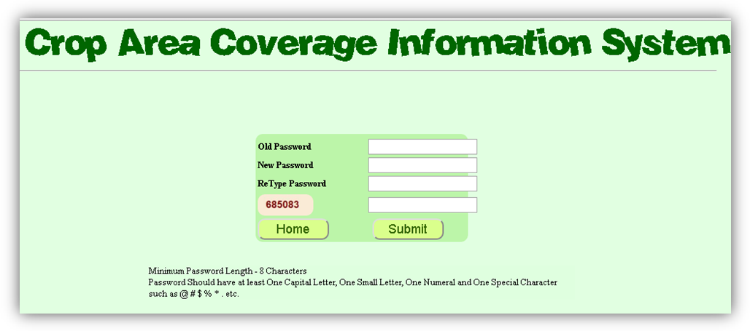
Enter Old Password, New Password, again New Password, Captcha Number and click Submit button. A screen will appear to confirm you that password has been changed successfully. You will be redirected to login again with new password. If something goes wrong then an error page will be displayed.

14. Logout Users are advised to logout from the system at the end of session.

15. Contact Details

In case of any operational difficulties/clarifications kindly contact NIC or DAC. We welcome your kind feedback/suggestions for the improvements of the system.

- Technical Contact

DV Singh, Pr Systems Analyst, NIC

Ph.23382267, Email: dv-singh@nic.in

Rakesh Vardhan, Technical Director, NIC

Ph.23383230, Email: rvardhan@nic.in

- Administrative Contact

Dr. S.K. Malhotra, Agriculture Commissioner, DAC, Ministry of Agriculture, GOI

Ph. 23383549, Email: ag.comm@nic.in

